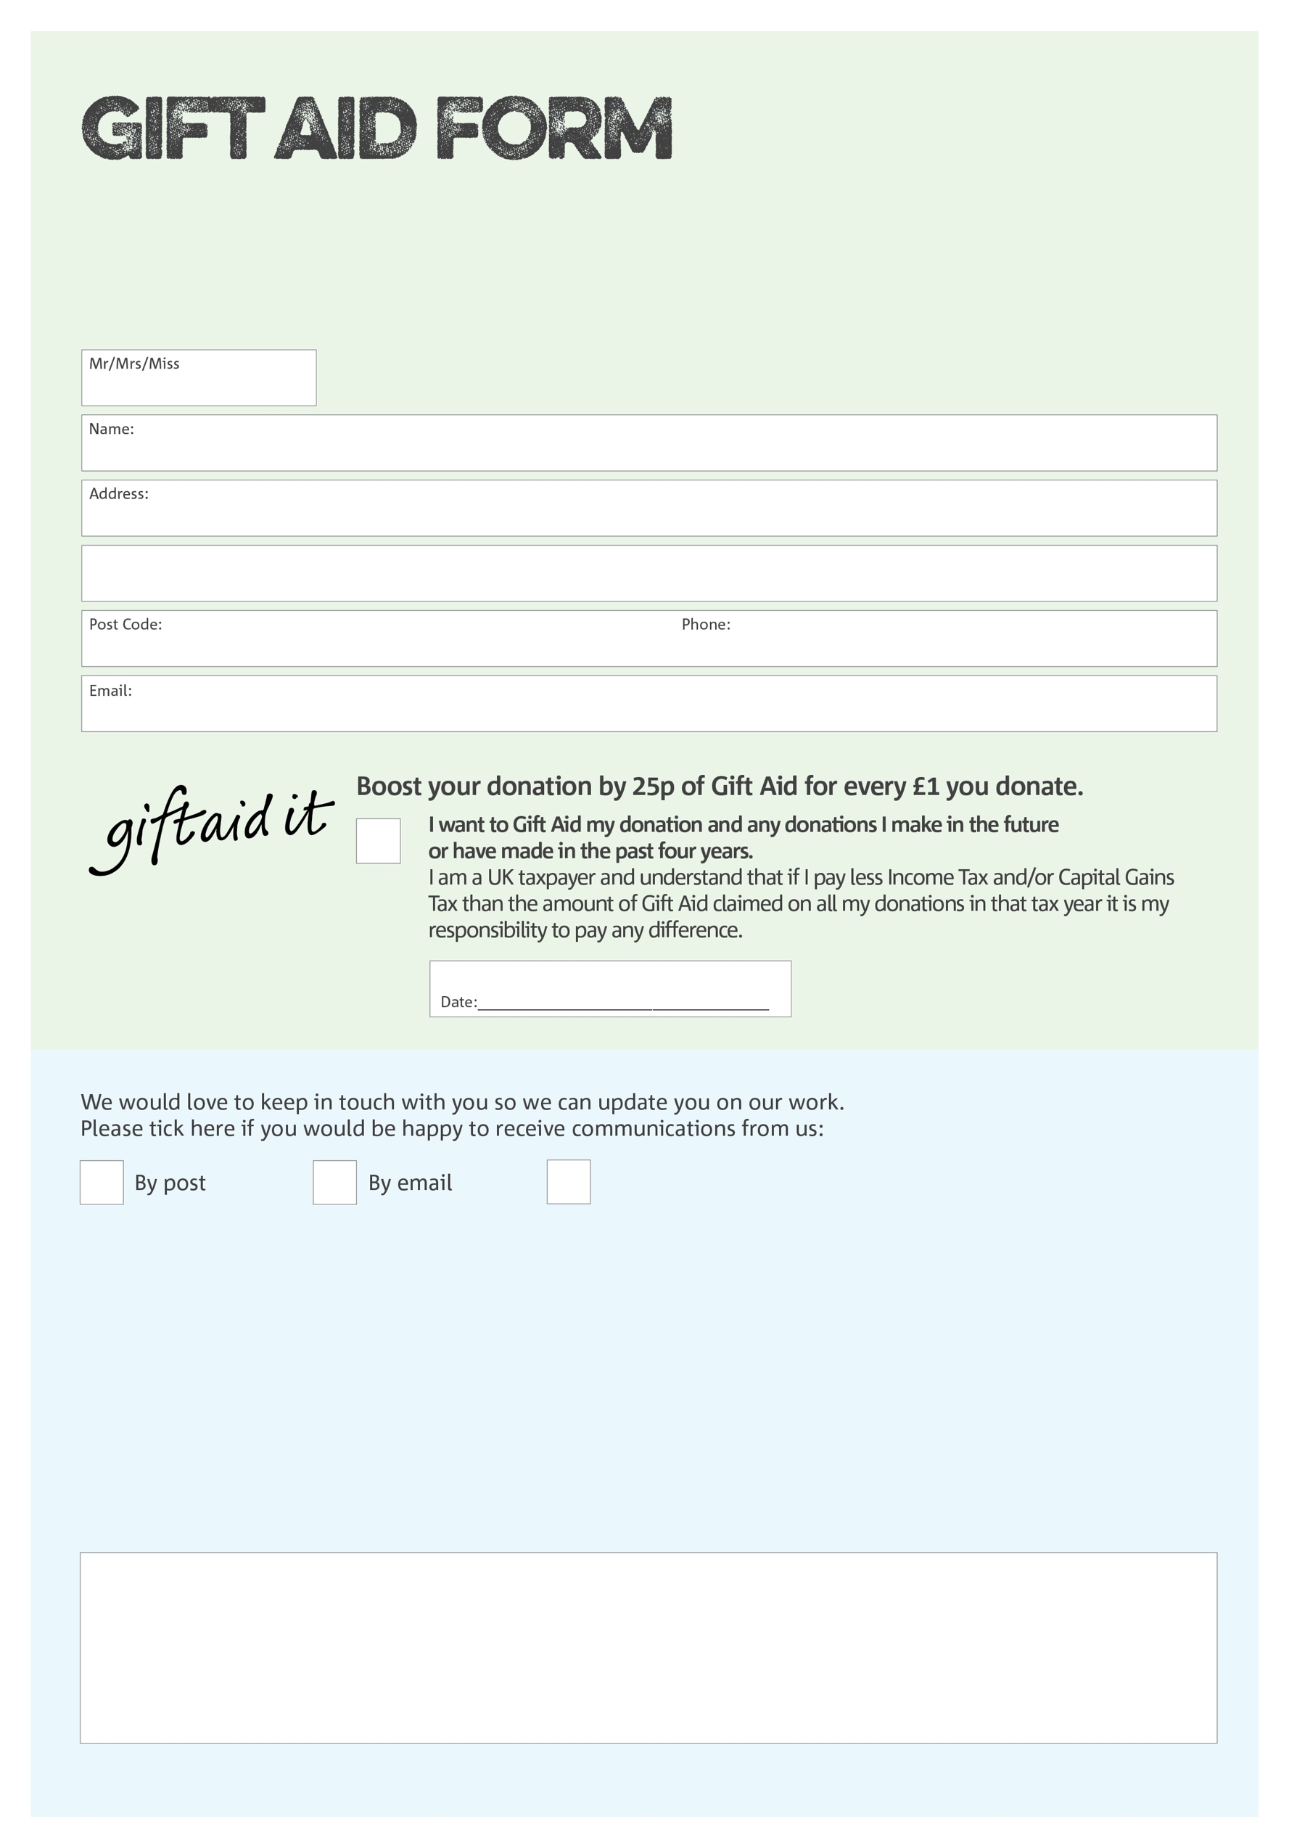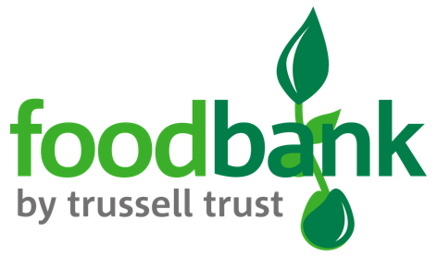

By filling in this form Barnsley Foodbank Partnership will receive an extra 25p for every £1 you give at no extra cost to you. Thank you!

**Data protection**

*“Barnsley Foodbank Partnership is committed to protecting your privacy and will process your personal data in accordance with current Data Protection legislation. Barnsley Foodbank Partnership collects information to keep in touch with you and supply you with information relating to our work. To unsubscribe from our newsletter, send a message to the email address above with the word unsubscribe in the subject line. A full data privacy statement for financial donors is available from the foodbank on request.’*

You can change your preferences any time by contacting us on 01226 235280 or emailing us at

Manager@barnsley.foodbank.org.uk

I do not wish to receive future communications from Barnsley Foodbank Partnership

We would love to know why you have chosen to donate to Barnsley Foodbank Partnership. If you would like to share your motivation let us know below:

Charity Number 1153906. Registered in England